**Indoor Explorer**

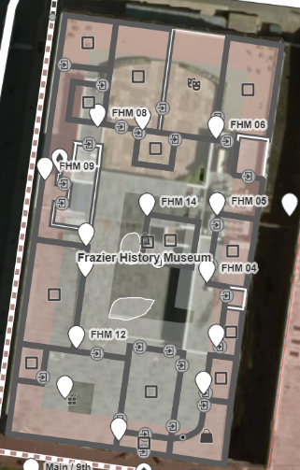

The Frazier History Museum is a 4 story 88,000 square foot building. It took 16 hours to mapped the first and second floors (44,000 sq ft). Installation will take two people approximately 16 hours to install 24 beacons. Cost: Pre-meetings: 3hrs X 2 X $20 = $120. Mapping: 16hrs X $20 = $320. Installation: 2 X $20 X 16hrs =$640. Beacons: $30 X 24 = $720. Total Cost = $1,800.

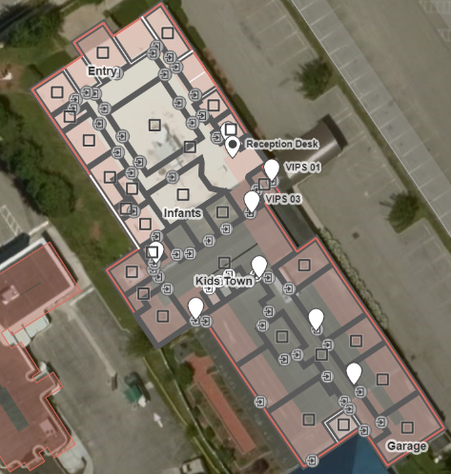

The Visually Impaired Preschool (VIPS) is a single story 17,000 square foot building. It took 8 hours to map. Installation took two people approximately 2 hours to install 8 beacons. Cost: Pre-meetings: 1hr X 2 X $20 = $40. Mapping: 8hrs X $20 = $160. Installation: 2 X $20 X 2 =$80. Beacons: $30 X 8 = $240. Total Cost = $520.

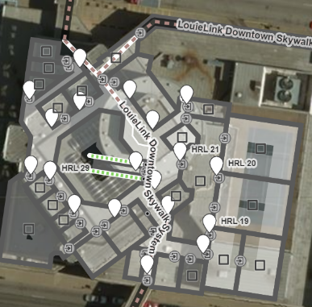

Hyatt Regency Hotel – APH mapped the first and second floor (78,750 sq ft). It took 24 hours to map. Installation took two people approximately 8 hours to install 22 beacons. Cost: Pre-meetings: 1hr X 2 X $22 = $44. Mapping: 24hrs X $22 = $528. Installation: 2 X $22 X 8hrs =$352. Beacons: $30 X 35 = $1,050. Total Cost = $1,986.

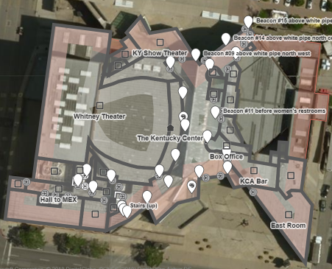

The Kentucky Preforming Arts Center - It took 24 hours to map the first floor of the building (87,500 sq ft). Installation took two people approximately 8 hours to install 22 beacons. Cost: Pre-meetings: 4hr X 2 X $22 = $176. Mapping: 24hrs X $22 = $528. Installation: 2 X $22 X 8 =$352. Beacons: $30 X 22 = $660. Total Cost = $1,716.

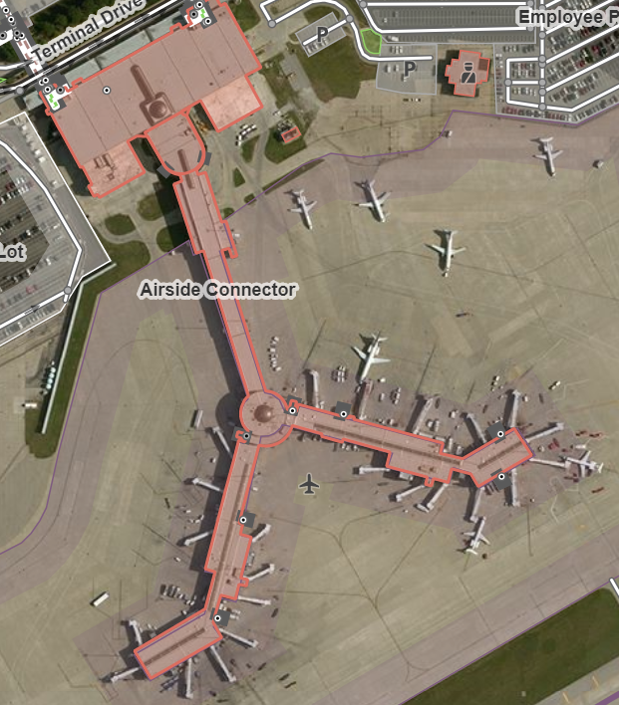

Louisville International Airport – we mapped 348,300 square feet of the building. It took 40 hours to map. Installation took two people approximately 16 hours to install 180 beacons. Cost: Pre-meetings: 20hr X 2 X $22 = $880. Mapping: 40hrs X $22 = $880. Installation: 2 X $22 X 16hrs =$704. Beacons: $30 X 180 = $5400. Total Cost = $7,864.

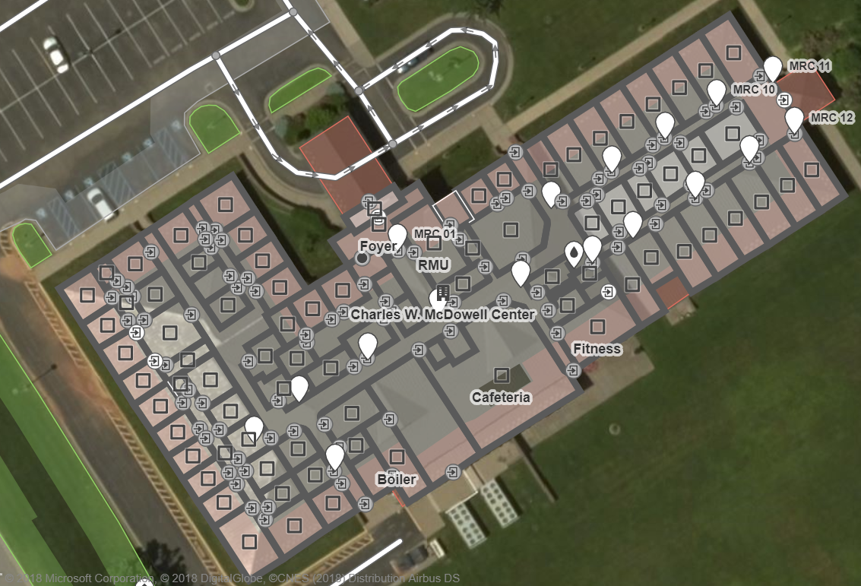

McDowell Center – we mapped 45,000 square feet of the building. It took 21 hours to map. Installation took two people approximately 10 hours to install 28 beacons. Cost: Pre-meetings: 4hr X 2 X $22 = $176. Mapping: 21hrs X $22 = $462. Installation: 2 X $22 X 10hrs =$440. Beacons: $30 X 28 = $840. Total Cost = $1,918.